**Zachary Satagaj**

**Problem A:** From the class conversation today, we learned that there are many ways to transform a graph. We use transform to better understand our model. Data can be stretch using square transform. The scattered plot below fits the green linear model at the bottom part, but not the points plotted at the top portion. Data in the list can be “stretch” to verify if the data points at the top portion will converged towards the linear model better.

Stretch = X2

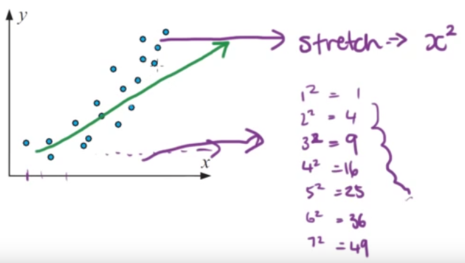

Smushing = Compressing = Condensing = or log10 y

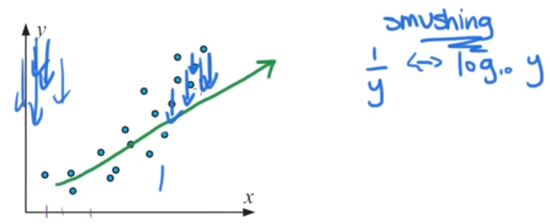

To compress data, a reciprocal or log() function can be applied to the data in a list. Another way of trying to fit the scatter plot to converge towards the linear model is to smush the scatter plot points at the top portion of the graph. A logarithmic function can be used to all data in the list to condense the data, and perhaps a determination can be made if this dataset is indeed following (fits) a liner model.

Therefore to linearize a curved, you can do one or two of the aforementioned transformations. The non-linear scatter plots below follows a curved model. Write down on the second column what kind of transform(s) you will do to fit the model to a linear graph. In other words, determine the appropriate transformation(s) to linearize the non-linear-shaped models below. Again, what type of data transformations you would do to made the curves below more linear.

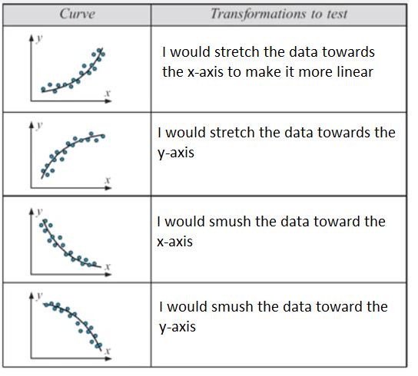

**Problem B:** Consider the dataset below:

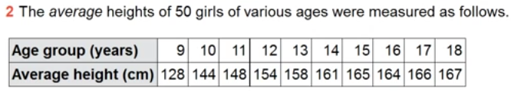

The original linear regression yielded a line with the expressions below:





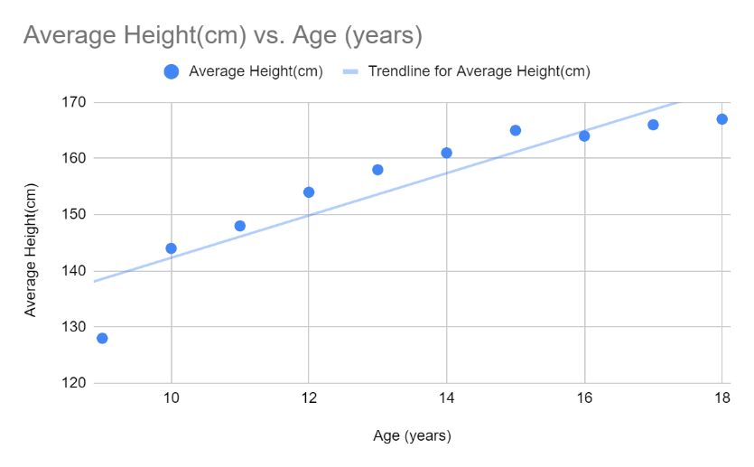

You may use any technique (and any tool including Excel) to plot the line. Make age as your x-axis, and height as your y-axis.



You may use any technique (and any tool including Excel, or manual method with the use of a calculator) to transform age to log(age), and plot the result.

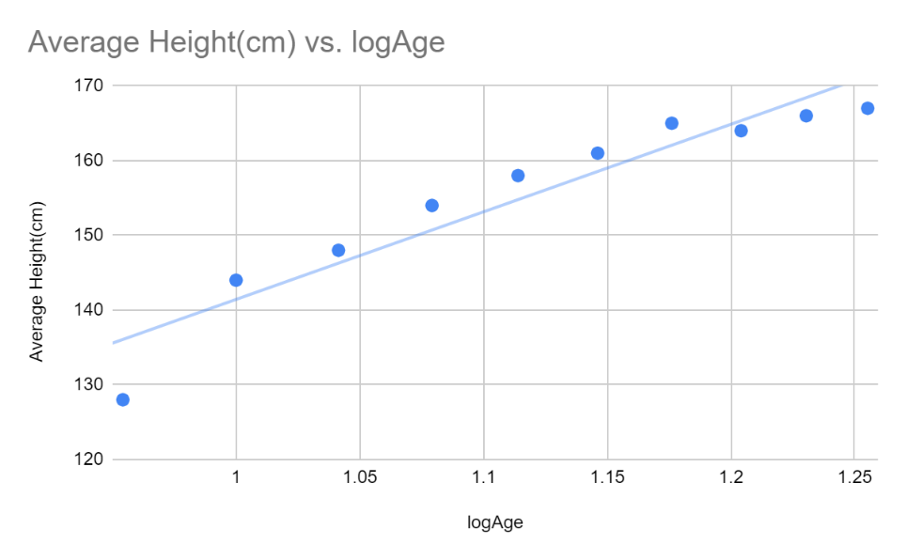

**c**  Did the log transform proved the linearity of the graph? In other words, is it straighter than before the transform? Defend your answer.

While the data is slightly straighter, I believe that the change is mostly negligible.

**d**  Comment on the suitability of transforming the data of question **b** in order to improve predictions for girls under 8 or over 18.

I think that the new data will be slightly better in predicting the heights of those under 8,

but the change is so small that the change may be unimportant in the grand scheme.

It might be better to use a square to predict the ages under 8, while the log would be

better for over 18.

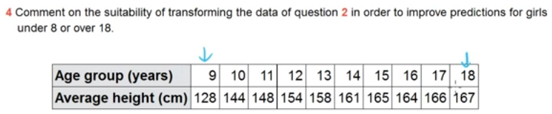

|  |  |  |  |  |
| --- | --- | --- | --- | --- |
| GRADING RUBRIC | | | | |
| Grading Criteria | **Exceeds**  *Excellent*  Epic Wow | **Meets**  *Satisfactory*  O.K. | **Partially Meets**  *Below Expectations*  Not Yet | **Does Not Meet**  *Unacceptable*  Fail |
| **Accuracy** | +35 - You exhibit excellent comprehension on the topic of data transformation and its accompanying tasks. | +27 - You showed satisfactory comprehension on the topic of data transformation. | +15 – The connection and comprehension on data transformation is “not yet” ready. | Unfortunately, no evidence of comprehension on the topic of data transformation. |
| **Completeness** | +10 – Completed all tasks assigned in a comprehensive manner. | +8 – Completed all or the majority of tasks in an okay fashion. | +2 – Not all tasks were completed. | Unfortunately, many parts of this assignment were not completed. |
| **Presentation** | +5 - Documentation was robust, showed design details including diagrams, and the “hows” were explained. | +3 - The document is okay but has room for improvement. Design details and the “hows” is satisfactory. | +1 – Documentation and design details are below expectation. | Unfortunately, no documentation, or no design details. |
| **Time Management** | You used time effectively and stayed within the timeframe allotted. | -5 Unfortunately, the work was not submitted on time. | -10 - Time management is poor and below expectation. | -15 - Unfortunately, this work is extremely late. |

**Solution:** Place your solution below on a separate page, and make sure your name is on your work before submitting to Canvas.